Using the Highland Historic Environment Record (HER)
HER: her.highland.gov.uk Highland Council’s database of all heritage, with links to canmore
Canmore: canmore.org.uk Scotland-wide database of heritage, run by HES, no links to the HER
pastmap: pastmap.org.uk The only way to check if there are records in both HER and Canmore
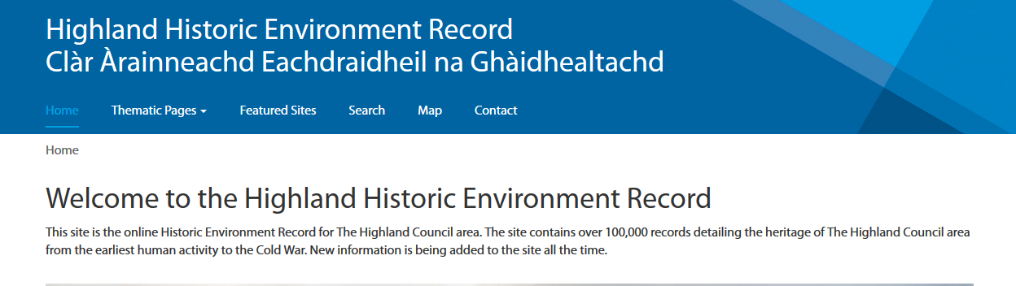
HER records
- Monument records MHGxxxx have details about sites and finds: searchable. Purple dots/outlines on the maps, and special symbols for listed buildings and scheduled monuments.
- Event records EHGxxx have details about work or research projects. Searchable. Yellow shaded polygons on the maps.
- Source records SHGxxx have links to sources, most available on line. Searchable
- Designations: allows you to just search listed buildings, scheduled monuments, designated battlefields etc
- HER records are consulted on all planning applications
Search menu
This now allows you to do a Simple Search, or Advanced Search
Simple search:
- First choose whether you want to search Monuments, Events, Designations or Sources
- This provides an ‘and’ search, but with option for exact match search
  - Search terms will bring up each record that the word occurs in – and this may not be in the location you searched for!
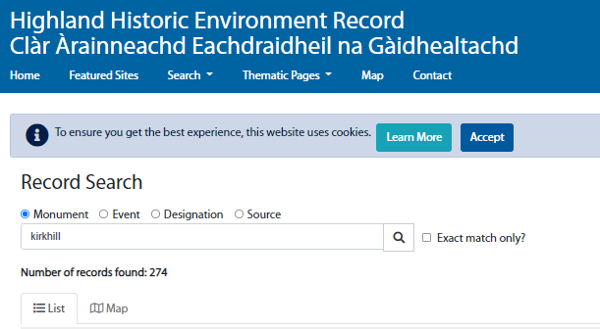
Advanced Search:
Now allows fielded searches! Some categories are more useful than others. For example, although in theory you can search by Time period, many sites are stored as ‘undated’ until further information is gained.

In both cases, there is an option to view the results as a list (default) or as dots on the map.
Use scroll bars to move down the list, and to select next page from the bottom. Click on the dot or name to select a record.
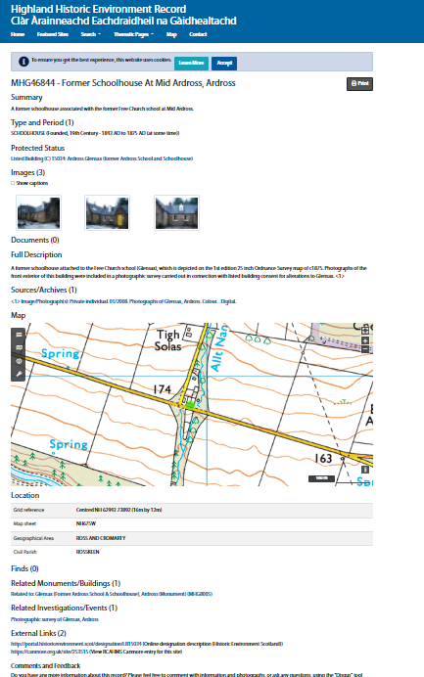
A typical HER Record
- Possible with a summary
- Type of monument or find, and period if known
- Whether it is listed or scheduled
- Possibly some images
- The Document section of a record often has links to files you can download. Some will be a single sheet and others will be multi-page reports
- A description which varies in detail. Often you can trace different theories over the years
- Sources
- A map view which can be zoomed in and out to a limited degree
- Details on parish, grid reference
- In some records, whether any finds were recorded from the site
- Records may also link to HES listed buildings and scheduled buildings portal, buildings at risk, and other relevant websites
- Links to related monuments or investigations. Some records are in a hierarchy: for example, the record for Reelig House (MHG15544) is the parent of a record describing the walled garden (MHG41073). They linked records may or may not have different text and pictures.
- External Links. This is an easy way to go to the Canmore record, and also to listed or scheduled monument information. Other links are sometimes placed there too.
- Comments and Feedback: a way to add information and pictures to the record (see next page)

Map Search and Map View:
- Can choose to see map view after keyword search, or can choose Map search from the main menu
  - Magnifying class brings up search box (only in Map View)
  - Lines in table: ‘Map Layers’ allows you to turn on/off the different types of sites
  - Wavy card: ‘Base Layers’ allows you to choose a base map
  - Table: ‘Record List’ allows you to generate a list of records
  - Tool: allows you to print or download (only in Map View)
- Icons on top right:
  - Diagonal arrow allows you to zoom to full screen
  - Plus and Minus symbol zooms in and out (mouse wheel also works)
- When zooming, Map View allows you to move across edges, but map in Search View only allows you to move a limited area
- Left click on dot or polygon to get a list of records at that location
Adding information and pictures
It’s easy to add pictures (in jpg format) or type in information about an existing record.
- Register/log in to Disqus at the bottom of the record. You will need an email address and a password
- Once logged in, click on Start the Discussion. This puts you in a box where you can start typing. You can format the text. There is a picture icon in the formatting tool bar. Click on this, and you can browse for the image on your computer.
For new records, you need to send the information to the HER her@highland.gov.uk, with the types of information you see on other records. A grid reference is essential! Grid references can be obtained from gps units, some smart phones, using the maps.nls.uk website (useful for sites on the 1st & 2nd edition OS maps) and other sources. If your grid reference is not precise, state this in the text.
Things to remember:
- All sites need a grid reference. Pay attention to the accuracy of the reference listed below the map on the record. A 10-digit grid reference is accurate, but 6 digit or less may not be in the exact location. It may also be very imprecise: for example, a find listed as from Ross-shire, is arbitrarily placed in Contin. In map view, the grid reference of the mouse pointer is shown on the bottom right.
- Acknowledge sources of text/information so that other readers can track down the information.
- Phrase your contributions carefully. If you have been told something, but have not proven it yourself, use the phrase ‘Local tradition is that…’ or similar
- You must have copyright permission for any pictures (including maps) that you upload, and copyright must be acknowledged. However, you can provide links to other websites with sources.

